Story by Brooklyn Eilers

Mrs. Melody Mesecher is the new 5th grade teacher at the elementary school. She grew up in Plainville, with one sister and many, many pets. She also graduated from Plainville High School. During high school, she was involved in Volleyball, Band, Choir, and National Honor Society. After high school, she attended college at MidAmerica Nazarene University in Olathe, KS. There she earned her Bachelor’s Degree in Psychology. She earned her Master’s Degree in Elementary Education online through the Grand Canyon University in Phoenix. She has a family of four now, including her husband, Jim, her daughter, Breanna, and her son, Ben. They currently live here in Plainville. In her free time she likes to ride her bicycle and she loves to read.
She has worked as a paraprofessional before, and eventually realized she wanted to teach, that is when she got her online degree. She also worked with the Parents as Teachers program. She has taught 5th grade at Sacred Heart Grade School the last 5 years here in Plainville. She decided to come teach at PES because she taught it was a cool experience to teach where she went to school, also, her children attend PES and PHS. She likes to teach 5th grade because she believes they are a fun age, they are getting into new experiences like band and sports, but they are still kids. Also, they are old enough to tie their shoes, but they are not teenagers yet. She loves teaching because she gets an opportunity to really impact students’ lives in positive ways. Also, she believes that for many kids, one single teacher can make a huge difference.
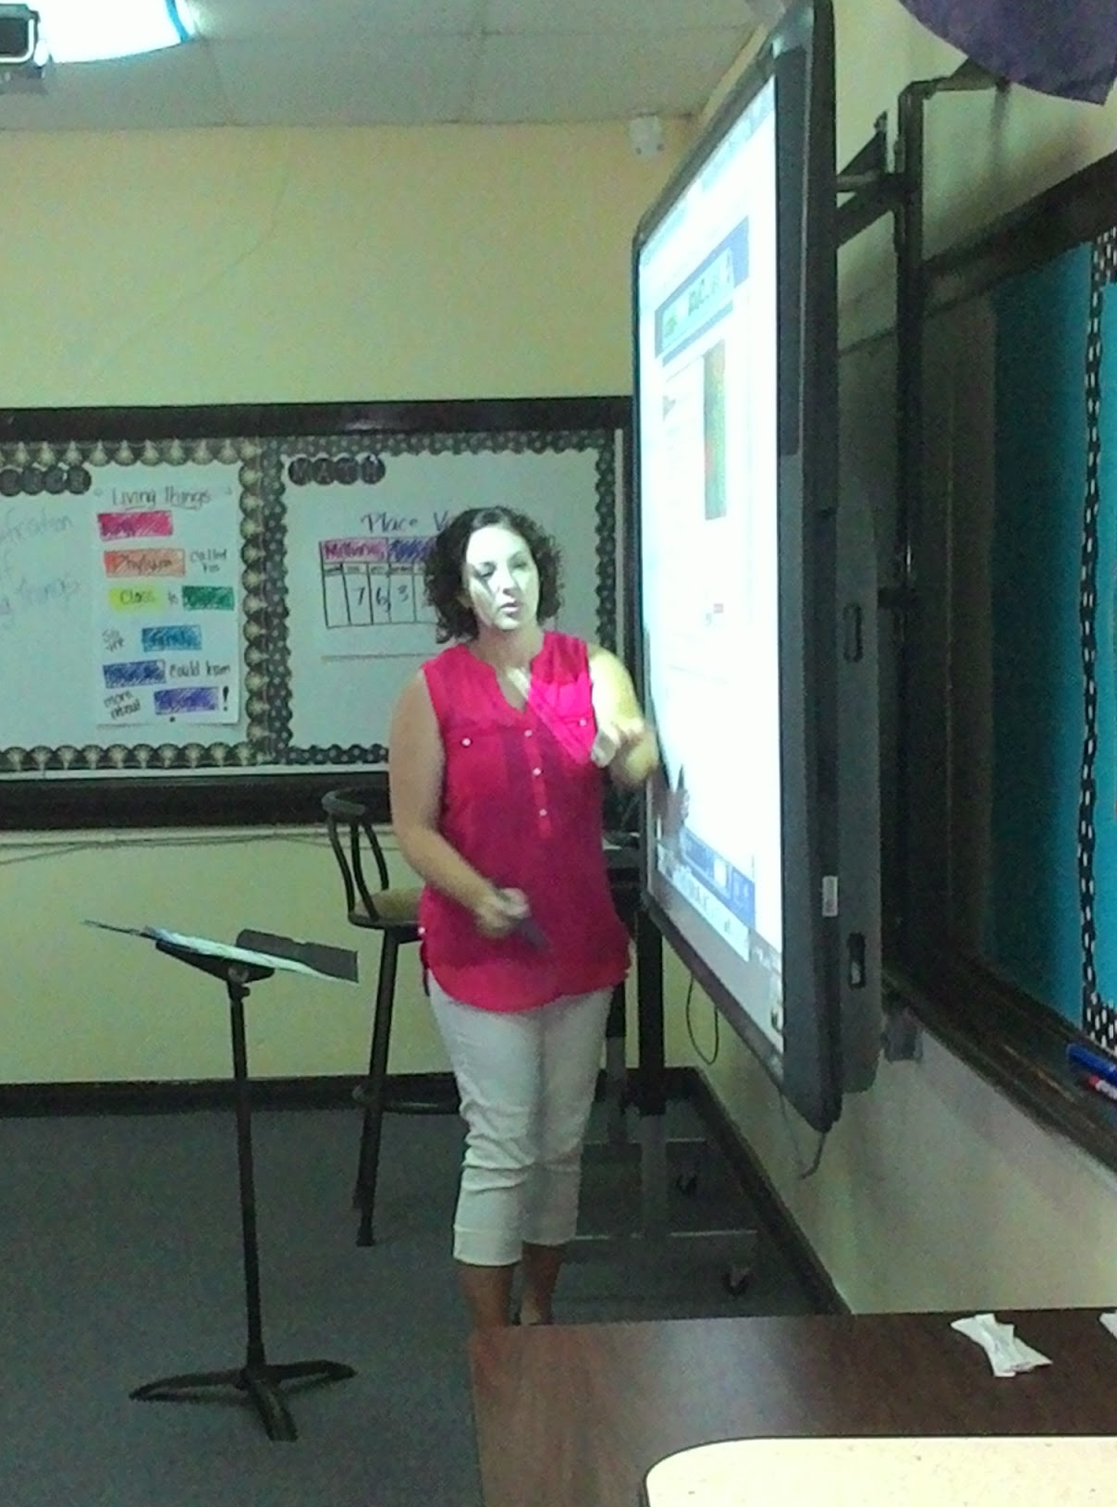
Her favorite subject in school was reading, because she loves to read; her favorite subject to teach is 5th grade social studies because it is about American History, and she thinks it’s pretty interesting. Her goal is to be able to look back through the year and see that she was successful in teaching the kids what they need to move on academically, also she wants to see that the kids become more responsible and reliable.

