Story by Kyle Carter
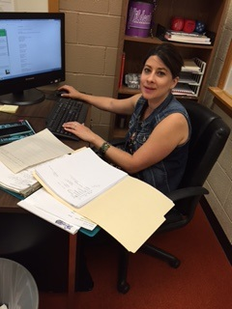
Emily Miller grew up in Hays, Kansas. She is now a teacher in the Resource Room. Her title is High school Interrelated Teacher. She came to Plainville after being offered the position with NCKSEC. As a teacher she enjoys seeing and working with the kids every day, She likes helping people achieve their goals. Every teacher has their favorite subject. Mrs. Miller’s include Reading and Life Skills. Her favorite thing about working here in Plainville is the kids and staff. She said if she wasn’t teaching she enjoys working with people so she’d like a profession including people or animals. She enjoys spending time with friends and family. Mrs. Miller attended Kansas State University, She loves the WildCats! She does not have any children currently. Mrs. Miller thinks the benefits of being a teacher are helping kids become smarter and successful. Some of her favorite sports teams are the Royals and the K-state Wildcats. Her favorite activity in high school was swimming. She enjoyed that the most and found it the most relaxing. Her family influenced her to become a teacher. They have been very supportive of her career and are very proud of her. Some of her favorite classes in college were writing and running classes. Everyone has a favorite color. Mrs. Miller’s is Blue. She has one dog which is a Shepard Husky mix. As many people Mrs. Miller’s Favorite memory of high school and college were the day she graduated. I got the chance to ask her what her favorite movie was, and she responded by saying Good Fellas. Overall I think she will be a great addition to the school and will be a great inspiration in the Resource Room.

