I interviewed Plainville’s new head football coach and Physical Education teacher, Grant Stephenson, to try and learn some more about the personal life of Coach Stephenson. I asked him some personal, football-related, and teaching/coaching questions. Here are his responses.

Q1: Where were you born?
A1: I was born in Lyons Kansas.

Q2: Where did you grow up?
A2: I grew up in Little River Kansas.

Q3:Do you have any siblings or pets?
A3: Yes, I had two brothers and two sisters, but no pets.

Q4: Where did you go to school?
A4: I went to Little River High School.

Q5: When did you start playing football?
A5: I started playing football when I was 12 years old.

Q6:Did you receive any scholarships to play football?
A6: Yes, I received a scholarship to Garden City Community College and Pittsburg State University.

Q7: Did you go to college to play football, or did you play football to help pay for college?
A7: A little bit of both.

Q8: Did you want any other career choices besides coaching/teaching?
A8: Yes, I started out going to school for business, and then changed to wood technology before I decided to teach and coach.

Q9: What college did you attend while playing football?
A9: I played at Garden City and Pittsburg State University.

Q10: What position(s) did you play in high school and college?
A10: In high school I played running back and defensive back. Then in college I played as the punter and free safety.

Q11: Have you coached anywhere else?
A11: Yes, I coached at Trinity Catholic High School, Fort Hays State University, TCU, and St. John Tipton

Q12:What made you want to be a coach/teacher?
A12: I enjoy being around the students, football, and weights. Just seemed to be the right fit.

Q13: Why did you choose to come and coach/teach in Plainville?
A13: I have a little boy Carter who lives in Hays. And I wanted to be close to him and still do what I enjoy...teaching and coaching.

Q14: Do you like the smaller school settings? or do you prefer bigger?
A14: I prefer the smaller school setting.

Q15: What do you enjoy most about coaching/teaching?
A15: Being around the students and watching them grow and progress, and the excitement of Friday night games.

Q16:What strengths of yours do you find helpful in coaching/teaching?
A16: It would have to be organization.

Q17:What do you think is the most difficult aspect of coaching/teaching today?
A17: Being able to adapt to ALL students and parents.

Q18: How do you plan to help contribute to our school community this year?
A18: By being a positive role model.

Q19: What are your goals for the current year?
A19: To start a winning tradition in football, and a good, fast work ethic in the weight room.

Q20: Do you have anything else that you would like to share with me?
A20: I think that’s it.

I think coach Stephenson will be a great addition to Plainville High School and cannot wait to see all the improvements he will make to our school district.

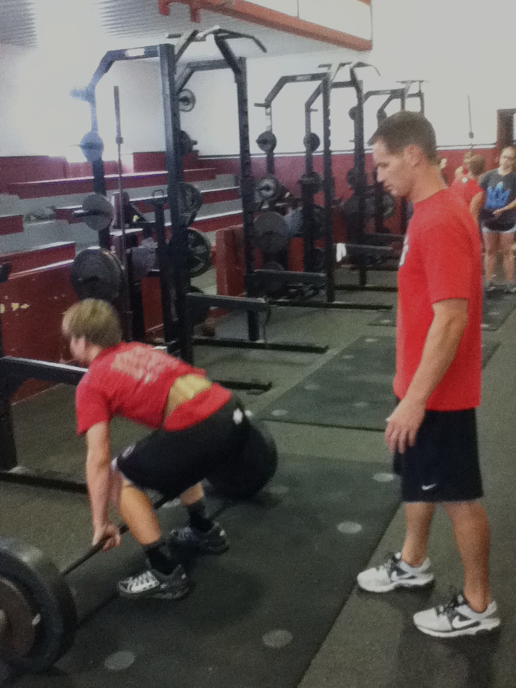
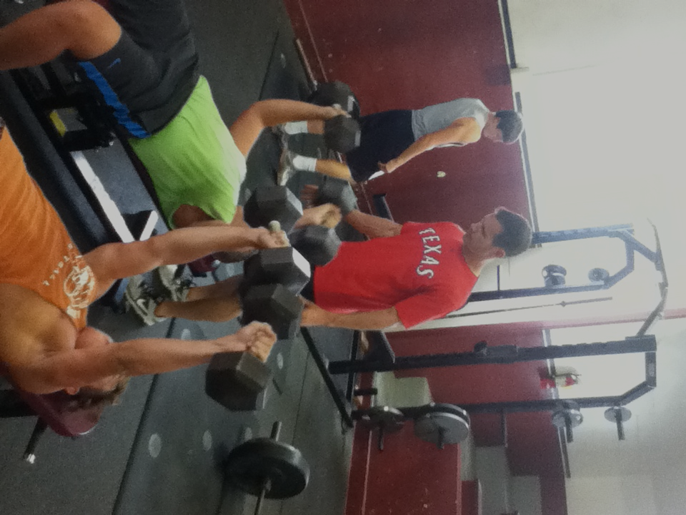
Story by Justin Reif

