Staab Interview Responses

Miss Staab grew up in Hays, Kansas being the oldest of four siblings. She danced a lot growing up. Her love for acting and singing got her involved in choir and shows the community put on. Other than acting, dancing, and singing, she would write in her free time and make up stories for fun. Her favorite activity in High School was the musical and school play.
Miss Staab graduated from Fort Hays State University last year. She currently still lives in Hays. She went to college seeking a degree in education. Ever since Kindergarten she has wanted to be a teacher because her teachers were such an inspiration to her. She wanted to teach Kindergarten, but she enjoys teaching third grade because at that age the students are learning to become more independent and she loves that. This is her first year of teaching. She student taught at Holy Family and Lincoln in Hays. While working toward her degree in education she worked at Mr. Goodcents Subs and Pasta, on the Fort Hays State campus, and as a dance instructor. Miss Staab has worked as a dance instructor for nine years now. Outside of teaching she still dances, writes, and sometimes joins in community theatre.
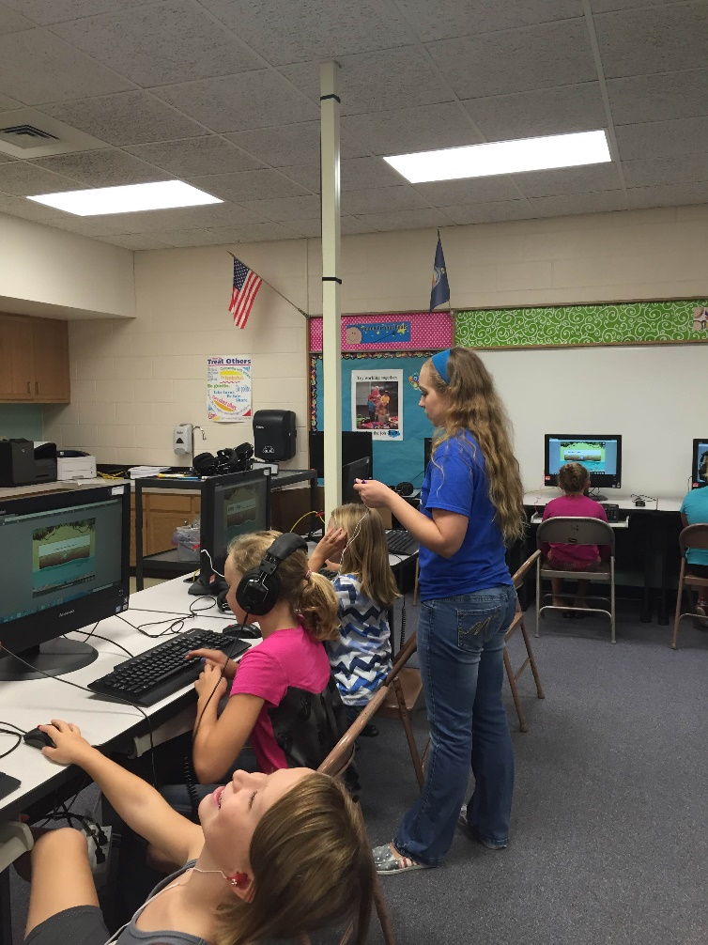
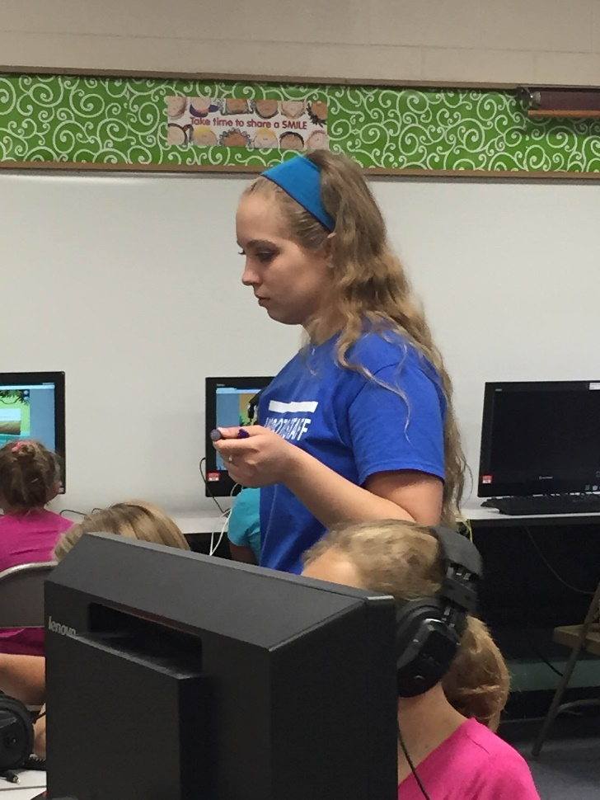
Plainville was a good choice for Miss Staab because it is close to her family and she loves smaller towns because everybody is more welcoming and it feels more like a “family” community. When asked what Miss Staab’s favorite part about teaching is she replied, “Seeing the smiles on my students' faces, either from something silly said in class or just because they finally understand a concept they have been working on for a while.” Miss Staab is detail-oriented, which is a strength that helps her in her teaching every day. Her favorite subject to teach is English, and her least favorite subject to teach is Science. She doesn’t necessarily dislike teaching it but growing up it wasn’t fun to her, so she is determined to add projects and more hands-on activities to make it more interesting. Miss Staab plans to contribute to the school community by being welcoming and friendly every day. Her goal for her classroom this year is helping her third graders realize that they are becoming “big kids” and help them grow into that role a little more every day.

Story by Jasmine Creighton

